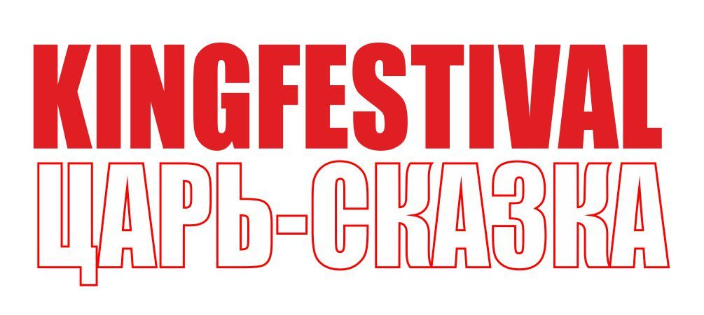
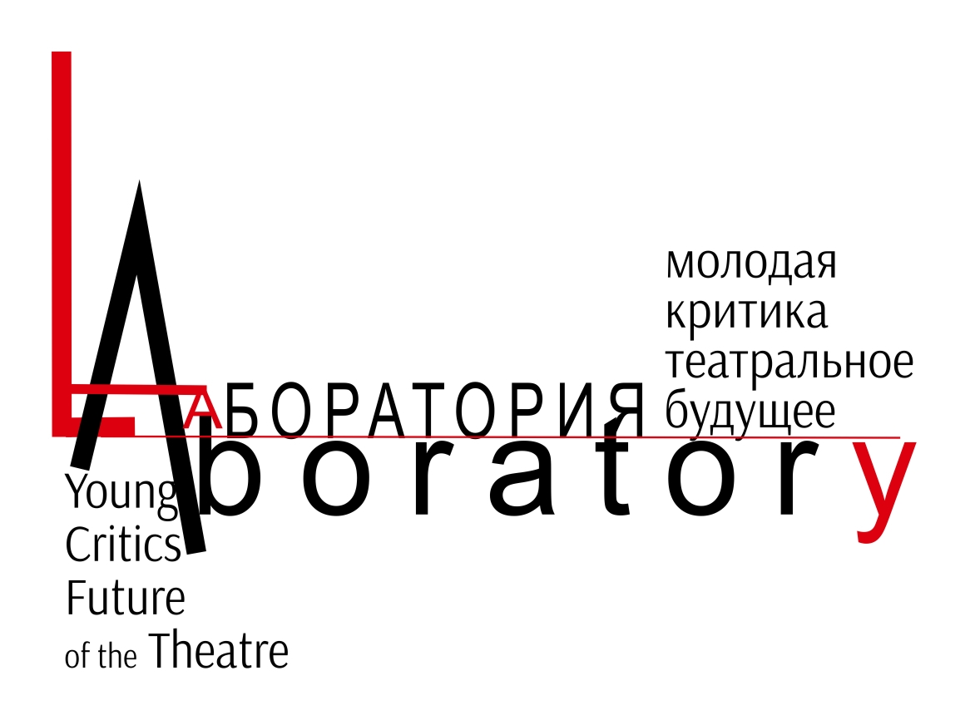

Application form
INTERNATIONAL CREATIVE LABORATORY
“YOUNG CRITICS – FUTURE OF THE THEATRE”

- First name/family name: _______________________________________
- Date of birthday: ________________________________________
- Country/city: ___________________________________________________________
- Education: _________________________________________________________________________

Work experience
- Publications :
_______________________________________________________________________________________________________________________________________________________________________________________________________________________________________________________________________________________
- Your motivation in participation:
____________________________________________________________________________________________________________________________________________________________________________________________________________________________________

7. Languages: _______________________________

8. Contacts
E-mail: ______________________________________________________
Phone: ______________________________________________________
Address: ____________________________________________________

Deadline till 1 February 2019
Please, send you application to Kingfestival@gmail.com
Tatiana Bobrova

